FINAL MODEL EVALUATION AND CREDIT-RISK SCORING.
-- We now move from model development to the part that makes the project look like a real credit-risk analytics solution.
-- One methodological cleanup first: our earlier threshold testing used the test set. For the final portfolio result, we should avoid using the test set to choose the threshold. We'll select the threshold from a validation split of the training data, then evaluate the locked model once on the test set.

FINAL MODEL EVALUATION
-- Our current candidate is the tuned Gradient Boosting model
learning_rate = 0.10
max_depth = 2
n_estimators = 200

Step 1 — Create a validation set from the training data
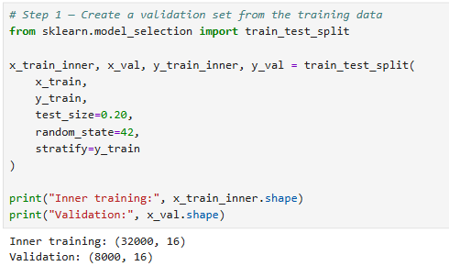

Step 2 — Create the tuned Gradient Boosting model again
-- We'll use the parameters discovered through tuning:
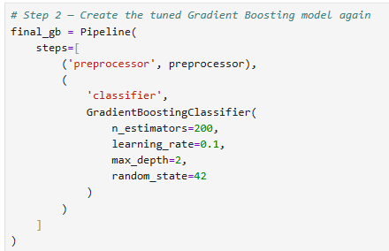

-- Train it on the inner training set:
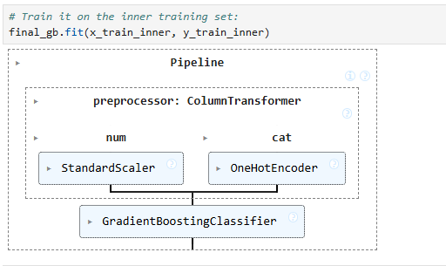

Step 3 — Select the threshold using validation data
-- Generate validation probabilities:
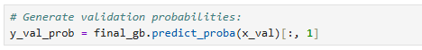

-- Test a wider range of thresholds:
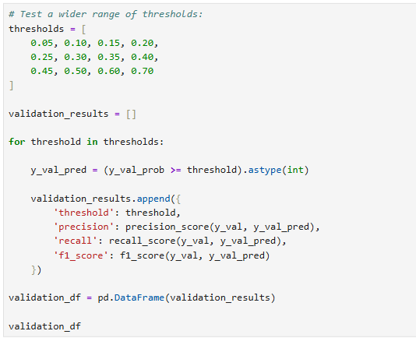

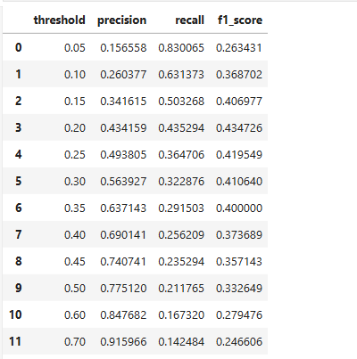

-- Then best validation threshold
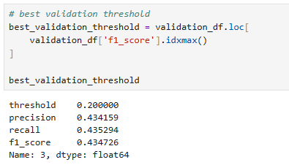

Step 4 — Retrain the final model
-- Now that we've selected the threshold, we can train the final model using all of the original training data.
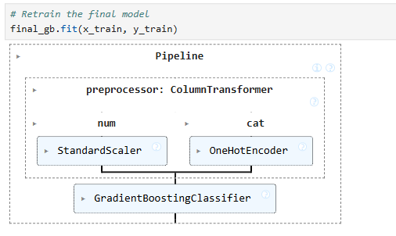

-- Generate probabilities for the untouched test set:
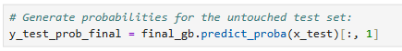

-- Apply the threshold selected from validation:
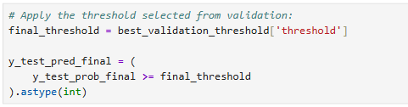

Step 5 — Final evaluation
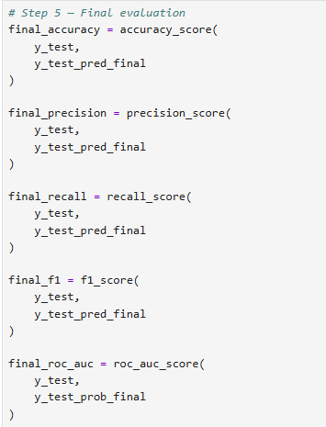
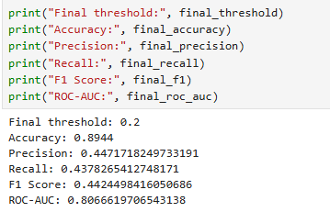

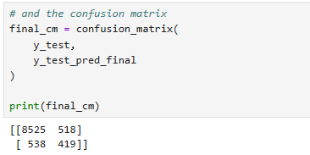

-- This is the evaluation we can eventually report in your portfolio.
-- The important difference is: The test set was not used to choose the model parameters or threshold. That makes the final performance estimate much more defensible.

CREDIT-RISK SCORING
-- Once the final model is locked, we can use its probability output to create a credit-risk score.
-- Our model produces something like:
Borrower A → 0.04
Borrower B → 0.13
Borrower C → 0.27
Borrower D → 0.61
-- These are predicted probabilities of default.
-- For your portfolio, we can create a simple 0–100 risk score where higher means greater predicted risk:
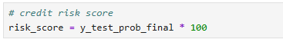

CREATE RISK BANDS
-- For the dashboard, we can initially create probability bands such as:

Predicted probability < 0.10 → Low risk
0.10 – <0.20 → Moderate risk
≥ 0.20 → Higher risk
-- But we should label these as portfolio/model risk bands, not claim that 20% is a universally appropriate lending cutoff.
-- The 0.20 threshold we've found is particularly useful because it was associated with the highest F1 among our tested thresholds, but the actual lending policy would depend on the institution's tolerance for false positives versus missed defaults.

BUILD A SCORING DATAFRAME
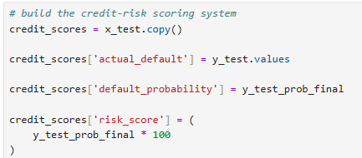
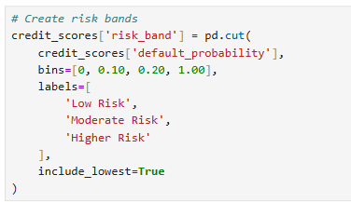
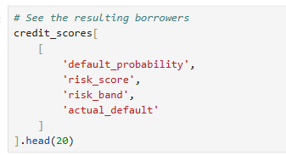
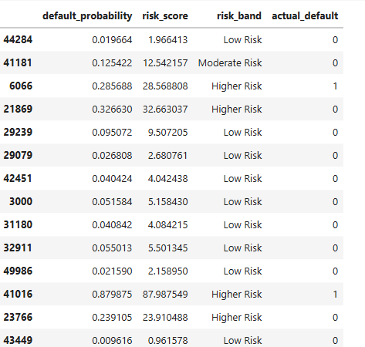

Analyze the risk bands
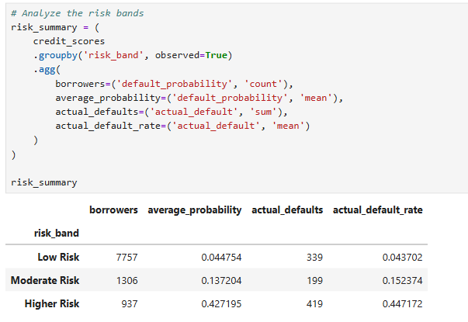
-- This will tell us:
- how many borrowers fall into each risk band
- average predicted default probability
- how many actually defaulted
- actual default rate within each band

-- Notice the progression: 4.37% → 15.24% → 44.72%. As the model's predicted risk increases, the observed default rate also increases. That's exactly what we want from a useful risk-segmentation system.
LOW RISK
-- There are 7,757 borrowers in this group.
-- Their Average predicted probability = 4.48% and Actual default rate = 4.37% are remarkably close.That suggests the model's low-risk group is reasonably well aligned with the observed outcomes in this test sample.

MODERATE RISK
-- There are 1,306 borrowers.
-- The model predicted an average probability of 13.72% while the observed default rate was 15.24% Again, the predicted and observed values are relatively close. The model is therefore distinguishing this group from the low-risk population.

HIGHER RISK
-- There are 937 borrowers.
-- Their average predicted probability was 42.72% and their actual default rate was 44.72%. This is important because the model isn't simply assigning arbitrary labels. The higher-risk group actually experienced a substantially higher default rate in the test data.
RESULTS/CONCLUSION
-- The final Gradient Boosting model achieved a ROC-AUC of 0.807 on the held-out test set. Using a 0.20 classification threshold selected on validation data, the model achieved 44.7% precision, 43.8% recall, and a 44.2% F1-score. Model-generated risk bands demonstrated increasing observed default rates across Low, Moderate, and Higher Risk groups: 4.37%, 15.24%, and 44.72%, respectively.

-- The final model currently stands at
- Gradient Boosting
- ROC-AUC: 0.8067
- Precision: 44.72%
- Recall: 43.78%
- F1: 44.24%
- Threshold: 0.20

-- And the risk segmentation behaved sensibly
- Low Risk → 4.37% actual default rate
- Moderate Risk → 15.24%
- Higher Risk → 44.72%
What’s covered:
- Data loading & inspection
- Target/default-rate analysis
- Univariate analysis
- Bivariate analysis
- Feature engineering
- Feature selection
  - leakage removal
  - correlation
  - VIF
- Train/test split
- Logistic Regression
- Logistic Regression threshold analysis
- Gradient Boosting
- Gradient Boosting threshold analysis
- Hyperparameter tuning
- Validation-based threshold selection
- Final test evaluation
- Credit-risk probability
- Risk score
- Low / Moderate / Higher risk segmentation
- Validation of the risk bands against actual defaults

-- The current model can continue being used as long as monitoring shows that it is still performing adequately.
-- If the SACCO gives you another 10,000 applications tomorrow, the existing model can score those new applications,
-- You could use the new data in different ways: Scoring only — no retraining. The model remains unchanged.AND retraining
-- So in a real SACCO system, you wouldn't necessarily retrain every time new data arrives. You would usually monitor the model and establish a retraining schedule or trigger.
-- So you would normally be required to manage updates/retraining, unless you build an automated ML pipeline that does this for you.

SACCO gets new applications
↓
New data is added to the system
↓
Existing model scores the applications
↓
Default probabilities / risk bands
↓
Monitor actual repayment outcomes
↓
Is model performance still acceptable?
↓
YES → Keep using model
│
NO
↓
Retrain with newer data
↓
Evaluate new model
↓
Deploy updated model

